Mega G+ Motor Change.
This is a brief guide on the changing of the motor for the Mega G+. It may not the only way, or the most efficient, but it will remove the motor and circuit board with the least chance of damage to all components.
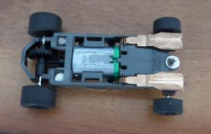

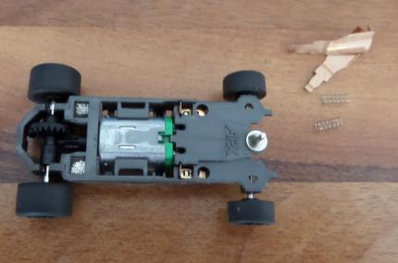
Remove Pickups and Springs. The rear axle can also be removed.

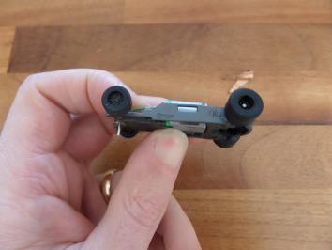
Gently push the base of the motor at the green endbell. The motor and circuit board will start to rise upwards.

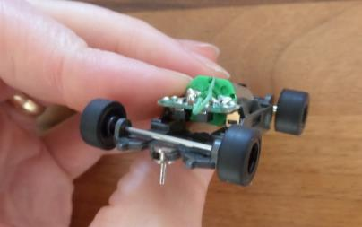
Gently push upwards. The circuit board may need to be lifted at the front as the pickup hanger can get caught on the chassis bulkheads.

Motor Out.
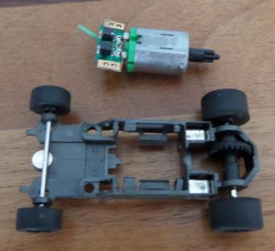

Replacement of the Motor – Place the motor atop the chassis. The pickup hangars are to be located in a groove, in-front of a bulkhead on the chassis. Ensure that these are positioned correctly to prevent damage.
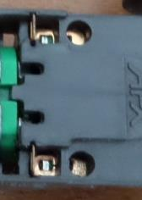
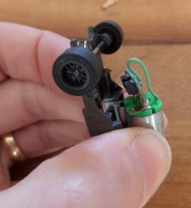

Ensure that the motor is flat and level and push it back into the chassis. A gentle click should be felt as the motor and circuit board and motors it positions itself into the chassis.
Replace the Pickup springs and shoes and carry on racing.
